Linked List Implementation Analysis Report

(1) Summary of Work
This project involved the implementation and performance analysis of two linked list variations: a Singly Linked List without a dummy header and a Circular Doubly Linked List with a dummy header. Both structures were implemented as template classes.
Implemented Approaches:
- NDLList: This implementation utilizes a raw header pointer that refers directly to the first data node. I implemented logic to handle special cases, such as inserting or removing at index 0, where the header pointer itself must be modified.
- CDLList: This implementation uses a dummy header to simplify pointer logic. The list is circular, meaning the dummy header’s prev points to the last node and the last node’s next points back to the header. As a doubly linked list, each node maintains next and prev pointers.
- Verification: Correctness was verified using a comprehensive driver program testing all public methods across multiple data types. Performance was measured using a timing driver.

(2) Template Compilation
Compiling template classes in C++ requires specific hadnling because templates are not actual code, but rather "blueprints" for the compiler to generate code when a specific data type is used. The compiler must see the full implementation at the point where the template is instantiated. Unlike standard classes where .h and .cpp are compiled separately, template implementations are typically included at the bottom of the header file using #include "FileName.cpp".

(3) Experimental Results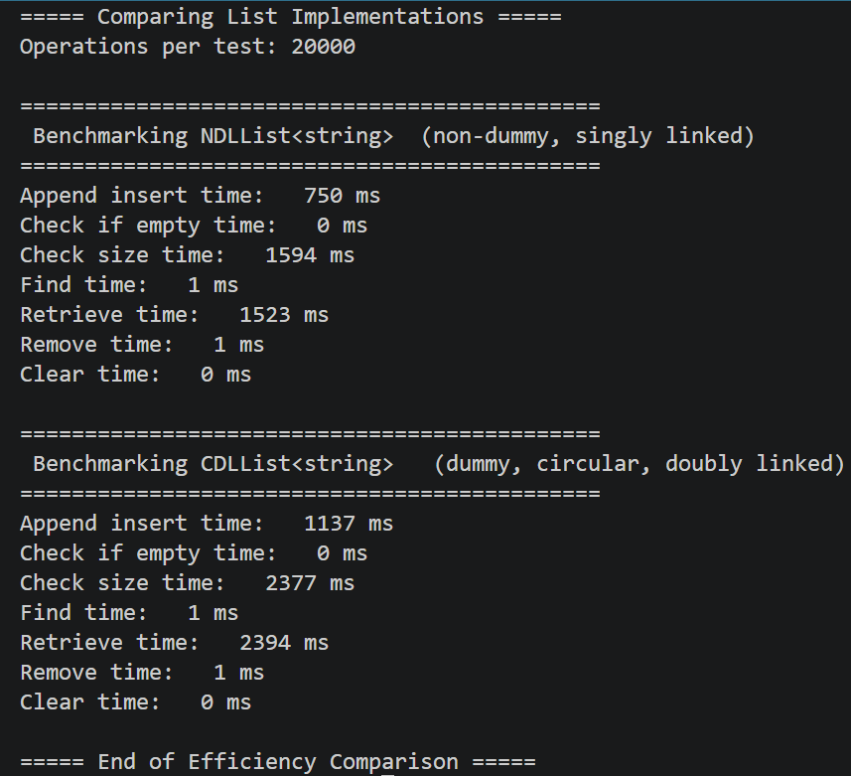

(4) Analysis
The experimental data reveals that while both implementations share the same Big-O complexity for these operations, the NDLList consistently outperformed the CDLList in traversal tasks. Inserting into a doubly linked list requires updating four pointers (newNode->next, newNode->prev, curr->next, and curr->next->prev), whereas a singly linked list only requires two. This doubling of pointer assignments leads to the higher "Append Insert" time in CDLList. Both size() and retrieve(N-1) require traversing the list from the beginning to the end. Because these are called N times in the benchmark loop, the total complexity is $O(N^{2}).$ The CDLList is slower during these traversals due to its larger node size (two pointers instead of one), which can lead to higher memory latency.

(5) Conclusion
The experiments demonstrate that the structural simplicity of a singly linked list makes it more efficient for simple forward-traversal tasks. However, the CDLList provides significantly more flexibility for multi directional traversal and simplifies edge-case handling through its dummy header, but there are performance trade-off in memory.
When working with template classes, developers must be extremely careful with header inclusion. Forgetting to include the .cpp in the .h file will lead to "undefined reference" errors during the linking stage, as the compiler won't know how to build the list for the specific types used in the main function.

(6) Use of AI Tools
For this assignment, I used Gemini (AI) to debug and refine my implementation logic.
Parts of the assignment asked about:
- Debugging Deletion: I encountered an issue where "apple" was not being deleted from the front of the list. The AI identified an "off-by-one" error where I was deleting the node after the target because I was using logic intended for a dummy header list.
- Circular Logic: The AI provided guidance on the 4-pointer update required for circular doubly linked lists and helped fix an infinite loop in my clear() and find() methods by replacing nullptr checks with header checks.

Date | In | Out | Tasks | Duration
4/3/2026 | 12:40am | 12:50am | Planning out implementation | 10 mins
4/4/2026 | 11:00pm | 12:30am | Writing Singly Linked List | 1hr 30 mins
4/5/2026 | 11:30pm | 12:10am | Finished Singly Linked List and start Circular | 40 mins
4/7/2026 | 9:20pm | 11:00pm | Finished Circular List Implementation | 1hr 40 mins
4/8/2026 | 10:00am | 11:30am | Wrote driver and benchmark | 1hr 30 mins
4/11/2026 | 11:00pm | 11:30pm | Finish up and write report | 30 mins
Total Hours |  |  |  | 6hrs

